Further Biology
Ben Mccartney (MED)
Further Biology
Dr. Kelly Edmunds
By

Functional groups

Properties of organic molecules depend on:
- The carbon skeleton
But also on...
- The molecular components attached to it

Functional group - The part of an organic molecule responsible for its chemical properties. It can be an atom, a group of atoms or C-C multiple bonds

The number, location and arrangement of functional groups give each molecule its unique properties.
- Hydroxyl group (R-OH) makes molecule polar and able to form hydrogen bonds with water.
- Carbonyl group (O=C-R) Ketone or aldehyde and is used to differentiate sugars, (see next page for diagram).
- Carboxyl group (combination of both of the above; R-COOH) Acidic properties due to being extremely polar
- Amino group (R-NH₂) Building block of the 20 different amino acids (which make proteins) and can act as a base

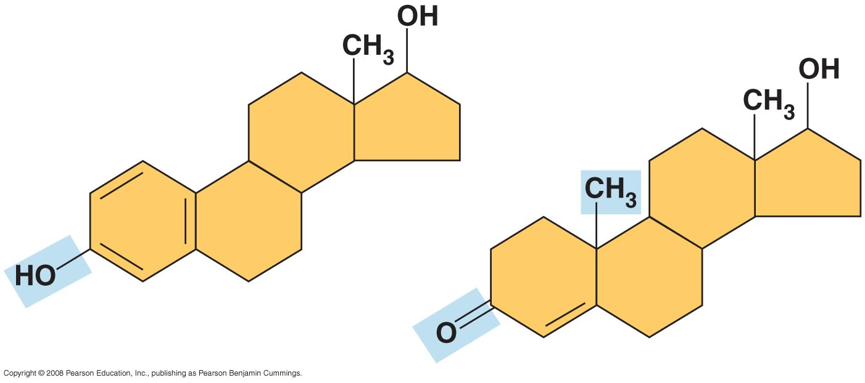
Example of the difference made by functional groups:
Testosterone
Estradiol
Estradiol = a form of oestrogen.
Differences in the functional groups of these steroid hormones result in marked differences in sexual characteristics between males & females.

macromolecules (general)
Cells contain 4 main types of macromolecule:
- Proteins
- Carbohydrates/Polysaccharides
- Nucleic acids
- Lipids
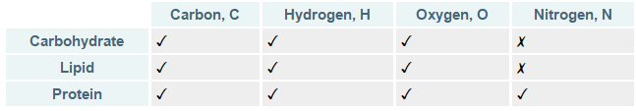
Most macromolecules are polymers (i.e. proteins and nucleic acids), and some are branched/linear (carbohydrates).
Polymer – Long chain consisting of monomers

polymers
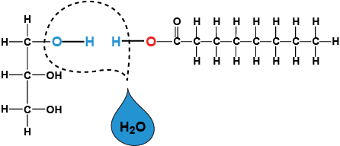
Made by joining 2 monomers with a covalent bond via a dehydration/condensation reaction. Uses ATP.
Polymers are broken into monomers via a hydrolysis reaction.

Carbohydrates
- Carbohydrates = sugars = polysaccharides
- Monomer = monosaccharide (simple sugar)
- Monosaccharide = 3-7 carbon atoms. They are any of the class of sugars (e.g. glucose and fructose) that cannot be hydrolysed to give a simpler sugar.
- Monosaccharide = multiples of CH₂O (C:H:O = 1:2:1)
- Glucose (C₆H₁₂O₆) = most important monosaccharide
- C-H bonds release energy when broken
- Hydroxyl groups (OH) make molecules polar

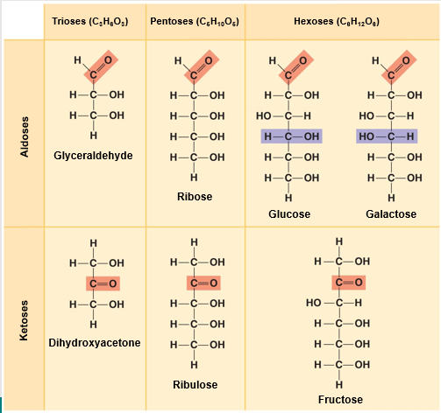
Monosaccharides
All have a carbonyl (C=O) and some hydroxyl (-OH) groups.
Classified by:
- Number of carbons in the carbon skeleton
- Location of the carbonyl group (as aldose or ketose)

In solution, most monosaccharides are not linear, but form rings
Common monosaccharides include:
- Glucose, C₆H₁₂O₆
- Galactose, C₆H₁₂O₆
- Fructose, C₆H₁₂O₆

All have same molecular formula but different arrangement of atoms – Structural isomers

Diaccharides
Consist of 2 monosaccharides joined together
They join in a dehydration reaction, forming a glycosidic linkage

Example (right): glucose & fructose forming sucrose

Functions
Monosaccharides:
Major nutrients and energy for cells
Glucose: key fuel for all cells
Raw material for making other kinds of biological molecules

Disaccharides often used for transport:
- Sucrose is moved around in plants
- Lactose (glucose + galactose) is in mammalian milk

Polysaccharides
- Consist of long chains of monosaccharides
- Usually polymers of glucose monomers
- Joined by glycosidic linkages (yields water)
- May be simple linear molecules
- But some are branched (more complex) &/or have cross-links between chains
- Different structures & functions depend on how the monomers are linked together

storage Polysaccharides

Starch:
- Plants
- Branched & unbranched forms
- See as large granules within chloroplasts
Glycogen:
- Animals
- Highly branched
- See as small granules (smaller than starch) in cytosol
- Lots in liver & muscle cells
Starch and glycogen are both alpha-glucose polysaccharides

Structural Polysaccharides
Cellulose:
- Beta-glucose polysaccharide
- O-H orientation makes it hard to digest
- Plant cell walls
- Hydrogen-bonding between chains gives strong microfibrils
- Most abundant organic compound on earth
- Animals can only digest cellulose if they have symbiotic bacteria in their guts
  - Cows
  - Termites
Chitin:
- Fungal cell walls and insect exoskeletons
- Monomers have an extra nitrogen-containing side-chain added to glucose

lipids
Poorly soluble in water however soluble in non-polar solvents.
Grouped dependent on solubility. The different groups are:
- Fats & oils – for energy storage, insulation and cushioning
- Phospholipids – animal cell membrane structure
- Steroids – for some hormones

Fats and Oils
- Oils are liquid fats. Lower melting point (due to structure), therefore liquid at room temperature
- Glycerol + 1-3 fatty acid chains (16-18 C long)
- Not polymers

Fatty acid:
- Long hydrocarbon chain – hydrophobic
- Usually 16-18 carbons
- Carboxyl (acid) group at the end
- Lots of C-H bonds = lots of energy; 9 calories/g

Saturated fatty acids (Fats)
- Saturated fats have all single C-C bonds
- Max number of hydrogens
- Straight chains
- Fats with saturated tails can pack tightly together
- Solid as have higher melting point than unsaturated fats

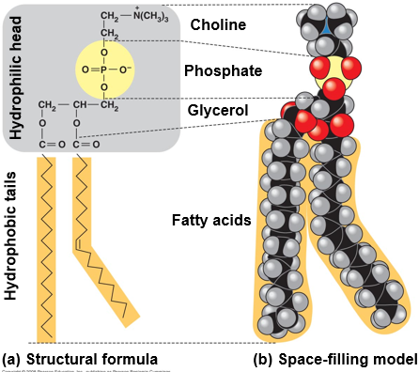
Unsaturated fatty acids (oils)
- Unsaturated fats have one or more double C=C bonds
- Kinks at cis double bonds
- Less compact due to kink as they can’t pack as closely
- I.e. Fish oils, plant oils

functions
- Energy storage
  - Compact – more than twice as much energy per gram as carbohydrates (9 calories/g compared to 4 calories/g in carbohydrates)
- Insulation (i.e. Whale Blubber)
- Cushioning of organs
Benefits of fats outweigh bad effects. Sugar is only stored or burned

phospholipids
- Long, hydrophobic tails with one saturated and the other unsaturated
- Charged, hydrophilic head

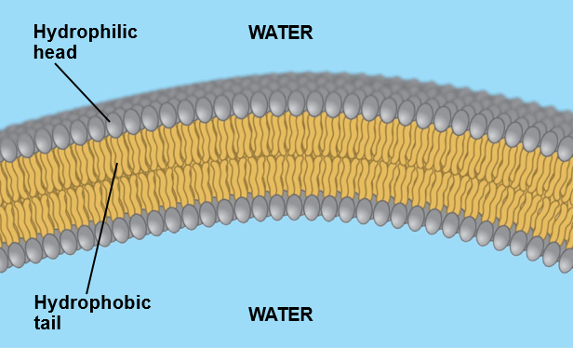
role in membranes
- Bilayer of phospholipids forms the basis of animal cell membranes
- Hydrophilic heads on the outside interacting with water
- Hydrophobic tails on the inside, interacting with one-another
- Unsaturated fatty acids with kinks help keep the membrane fluid. More kinks = more fluid.

steroids
- Carbon skeleton of 4 fused rings with side-chains & functional groups give differences

Cholesterol
- Component of (animal) cell membranes
  - Cholesterol is a rigid molecule that wedges between phospholipids giving the membrane greater stability and reducing fluidity.
- Precursor in synthesis of steroid hormones
- High levels may increase risk of atherosclerosis (thickening of artery walls, can lead to blockage of artery)

Steroid hormones
- ‘Sex hormones’:
  - Oestrogens
  - Testosterone
  - Progesterone
- Cortisol (the stress hormone)
- Ecdysone (insect hormone that triggers moulting)
Small differences in structures – big differences in effects (see Estradiol and Testosterone on page 1)

bile salts – polar derivative of cholesterol
- Made in liver – released into small intestine
- Emulsify fats – small fat droplets produced by emulsification are easier to digest

proteins
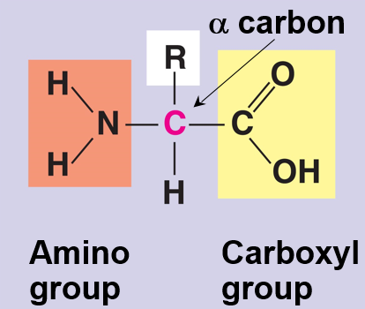
Proteins are large molecules made from smaller units of amino acids. Which has a common structure:
- Alpha carbon linked to …
  - Carboxyl group
  - Amino group
  - R group – different in different amino acids
Physical properties:
- Non-polar - e.g. alanine, leucine, glycine
- Polar - e.g. serine, tyrosine, glutamine
- Charged - e.g. glutamic acid, aspartic acid, lysine (basic)

Structure
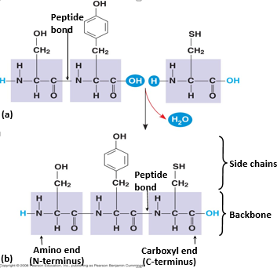
There are only about 20 different naturally-occurring amino acids (essential amino acids must be obtained from diet. From Meat or beans + grains). However, each protein molecule has hundreds, or even thousands, of them joined together in a unique sequence and folded into the correct shape. This gives each protein its own individual properties, such as being charged, polar or not. All of the different properties depend on the R group. They are linked by peptide bonds.

Primary
Primary Structure: The unique sequence of amino acids that makes up a protein or polypeptide chain. Linked by peptide bonds. Determined by our genetic code, which then determines the folding of the next level.

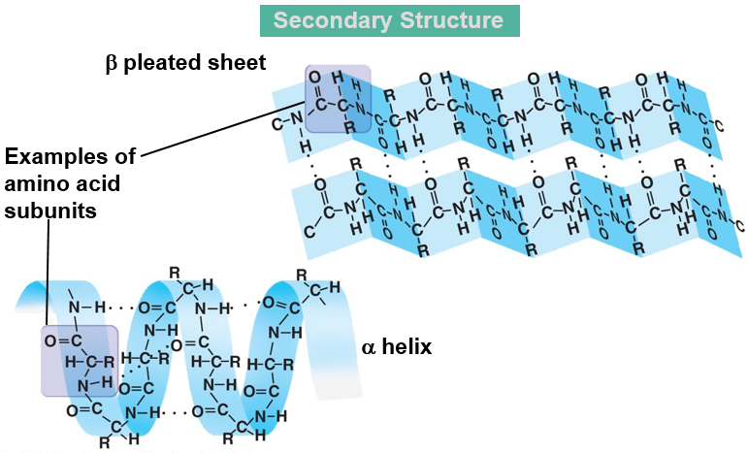
secondary
Secondary Structure: The way in which the primary structure of a polypeptide chain folds.

Held together by many Hydrogen bonds (between C=O and N-H), overall giving the shape great stability.
Does not involve the side chains (R-groups)
- Alpha helix (α helix)
- Beta pleated sheet (β sheet) – parallel sections of hydrogen bonding. Slightly elastic properties.
Can have both in a protein

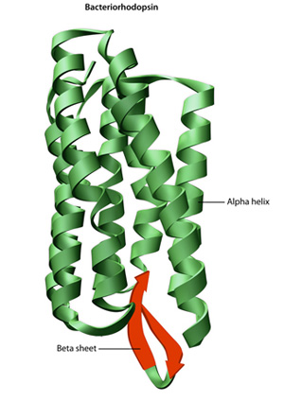
Protein mostly composed of alpha helix: Haemoglobin

Example of a protein mostly composed of beta pleated sheets: silk fibroin

tertiary
Tertiary Structure: This is the overall 3-D structure of the protein.

Mainly determined by side chains
- Interaction with water
  - Interior usually hydrophobic (as proteins are often in aqueous solutions)
- Interaction with one another
Tertiary structure is held together by four different bonds and interactions:
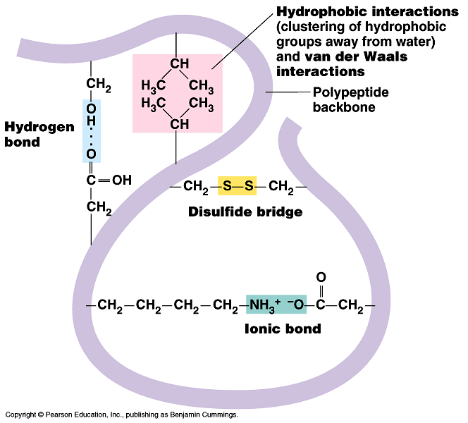
- Disulphide Bonds - Where two Cysteine amino acids are found together, a strong double bond (S=S) is formed between the Sulphur atoms within the Cysteine monomers. Normally S-S single bond.
- Ionic Bonds - If two oppositely charged 'R' groups (+ve and -ve) are found close to each other, and ionic bond forms between them.
- Hydrogen Bonds
- Hydrophobic and Hydrophilic Interactions - Some amino acids may be hydrophobic while others are hydrophilic. In a water based environment, a globular protein will orientate itself such that it's hydrophobic parts are towards its centre and its hydrophilic parts are towards its edges
Proteins with a 3D structure fall into two main types:
- Globular - These tend to form ball-like structures where hydrophobic parts are towards the center and hydrophilic are towards the edges, which makes them water soluble. They usually have metabolic roles, for example: enzymes in all organisms, Thrombin, Alpha and Beta globin, Albumins and antibodies in mammals.
- Fibrous - They proteins form long fibres and mostly consist of repeated sequences of amino acids which are insoluble in water. They usually have structural roles, such as: Collagen in bone and cartilage, Keratin in fingernails and hair.

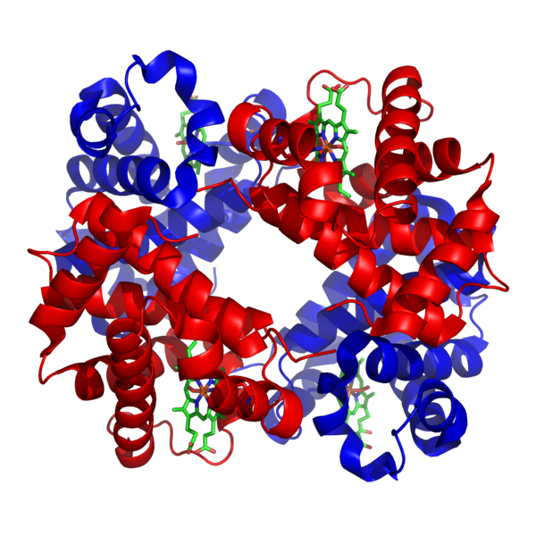
quaternary
Quaternary Structure: The structure formed when two or more polypeptide chains join together, sometimes with an inorganic component, to form a protein.
I.e. Haemoglobin as it is made up of alpha and beta chain haemoglobin and Iron.

function
- Structural
  - Collagen
    - Tough fibers
    - Most abundant protein in human body
    - Bone, cartilage, connective tissue
  - Keratin
    - Hair, nails, skin cells
- Contractile
  - Actin and Myosin
    - Work together in muscle contraction
- Transport
  - Haemoglobin
  - Membrane transport proteins
- Hormones
  - Insulin & glucagon – blood glucose moderators
- Receptors
  - Cell-surface hormone receptors
  - Antibodies & T-cell receptors
- Enzymes (globular proteins)
  - Biological catalysts
  - Speed up reactions by providing an alternative reaction pathway of lower activation energy

nucleic acids

Nucleic acids are polymers of nucleotides. Their function is to:

- Carry genetic information
- Store, and pass on in reproduction (DNA)
- Carry instructions for protein synthesis within the cell (RNA)

nucleotides
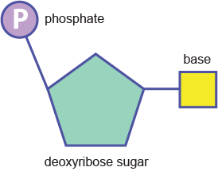
Nucleic Acids (DNA and RNA) are polymers and their monomers are Nucleotides. Each nucleotide is composed of:
- a Pentose Sugar (Deoxyribose in DNA and Ribose in RNA)
- an Organic Nitrogenous Base (A, T, C, G, U)
- a Phosphate Group – AMP, ADP, ATP
Nucleotides joined by phosphodiester linkages
Base + sugar = nucleoside
Nucleoside + phosphate = nucleotide/

Nucleotide functions
- ATP / ADP
  - Energy currency
  - cAMP (cyclic AMP) is a chemical messenger in some organisms
- GDP / GTP
  - Energy currency in a few reactions
  - Messenger inside cells

bases
The organic bases are grouped into Pyrimidines and Purines. Pyrimidines are smaller as they contain a single ringed structure, whereas Purines are larger as they contain a double ring structure.
The Pyrimidines are (single 6 C ring):
- Thymine (in DNA)
- Uracil (in RNA)
- Cytosine
The Purines (double 5 and 6 carbon ring fused) are:
- Adenine
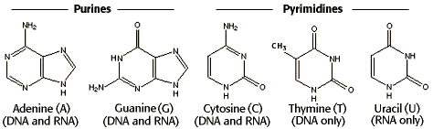
- Guanine
If one has too much Nucleic Acid, especially in one's extremities, one may develop a condition known as Gout. In the liver, excess Purines are broken down in Uric Acid, which is then excreted in the urine. However, if one's blood contains too much of this Uric Acid, it may form crystals that are deposited in the joints, which can be particularly painful.
When DNA is copied, these complementary bases are inserted: ensures fidelity.

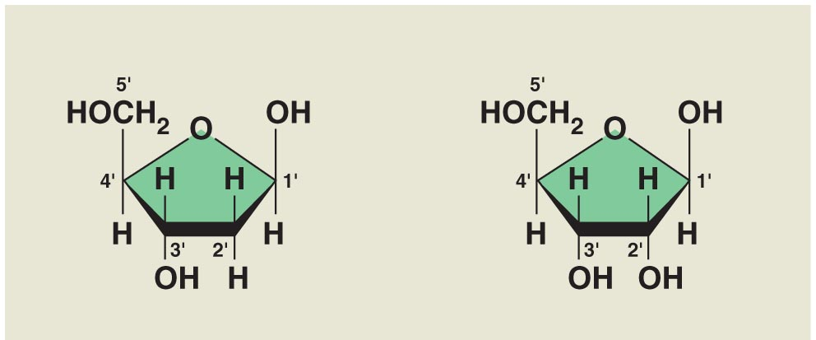
sugars
- Pentose sugars (5 carbons)
- Deoxyribose (DNA)
- Ribose (RNA)

phosphate
1, 2 or 3 phosphate groups:
Figure 1: Deoxyribose and Ribose
- Adenosine monophosphate (AMP)
- Adenosine diphosphate (ADP)
- Adenosine triphosphate (ATP)

POLYNUCLEOTIDES
Nucleotides joined by phosphodiester linkages
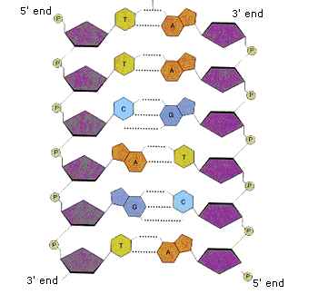
- Sugar-phosphate backbone
  - Bases protrude
- available for recognition / pairing with other bases
- Ends of a polynucleotide named for the end sugar carbon
  - 5’ and 3’ (5-prime & 3-prime)

RNA VS DNA
- RNA molecules are a single polynucleotide chain
- DNA molecules consist of 2 chains wrapped around one another
- RNA made of A - G - C – U (uracil)
- DNA made of A - G - C – T (thymine)
- DNA molecules usually longer (due to junk sections). In RNA junk sections are spliced out.

dna
DNA (Deoxyribonucleic Acid) is composed of two Polynucleotide Strands (the polymers of nucleotides), which form what looks like a ladder. The Nitrogenous Bases in DNA store the instructions for making polypeptide chains, essentially coding for every feature of the entire organism.
The two polynucleotide strands run 'antiparallel' to each other, with Nitrogenous Bases projecting inwards. The term 'antiparallel' means that the strands run in opposite directions, parallel to one another. 5’ to 3’ (the way we and enzymes read it). The antiparallel strands twist in a complete DNA structure, forming a Double Helix.
The strands are held together by Hydrogen Bonds between the Nitrogenous Bases that are opposite each other. Bases bonded together are termed 'paired', and are very specific as to which Base they will join to. A Purine will only pair with a Pyrimidine. Not only that, but the Adenine Purine will only pair with the Thymine Pyrimidine (A-T), and the Guanine Purine will only pair with the Cytosine Pyrimidine (G-C). These base pairings are termed Complementary Base Pairings.
The reason that Purines will only bond with Pyrimidines is that Purines are larger molecules (composed of a double ring structure), so in order to ensure that the polynucleotide strands are equally spaced apart, the larger Bases must pair with the smaller bases. The root for the specific Complementary Base Pairings is the number of Hydrogen bonding sites available. Adenine and Thymine have two sites each, whereas Guanine and Cytosine have three sites each. Complementary base baring ensures fidelity (the degree of exactness with which something is copied or reproduced).
Some amino acids are coded for by many codons so that if there is an error, it won’t affect the protein structure (degenerate) as the correct amino acid will still be coded for.

metabolism (overview)
- Metabolism = The sum of all chemical reactions in a cell
- Within a cell, thousands of different chemical reactions occur
- Collective term for all the different chemical reactions in all an organism’s cells is metabolism
- Biochemistry is the branch of biology that seeks to understand these reactions and how they are controlled
- Nearly all reactions are catalysed by a specific enzyme
- Most reactions can be thought of as part of metabolic pathways

enzymes
- Enzymes are protein catalysts that increase the rate of reaction (by facilitating the molecular rearrangements that support cell function) without being used up (aren’t involved in the reaction).
- Without enzymes, most metabolic reactions would occur too slowly to keep cells functioning.
- Because they catalyse metabolic reactions, they are thought to be part of the metabolic pathway
- Nearly all enzymes are proteins (small number are special RNA molecules).
- Enzymes are typically large globular proteins, each with a specific 3D shape which binds with the substrate molecule(s). This is called the active site.
  - Specificity of the active site is due to the shape of the active site and the R groups of the amino acids surrounding the site.
  - Enzyme + Substrate (can be 2 or more to make a polymer by using energy or catabolic releasing energy) = Enzyme-substrate complex
- Location of an enzyme is dependent by whether it has access to substrates

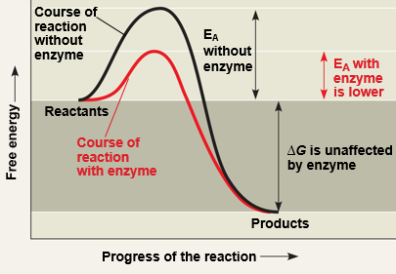
how they work
- They don’t change the energy released or consumed in the reaction
- Work by lowering the activation energy required for a particular reaction, (amount of energy that is needed to convert the reactants into the products).
- They can also increase the likelihood of substrates coming into contact with each other; increasing the number of collisions.
- The active sites bind only particular molecules – this is what makes enzymes specific
  - Specificity conferred by:
  - Shape of active site (lock and key)
  - R groups of amino acids surrounding site
  - ‘Induced fit’ upon binding

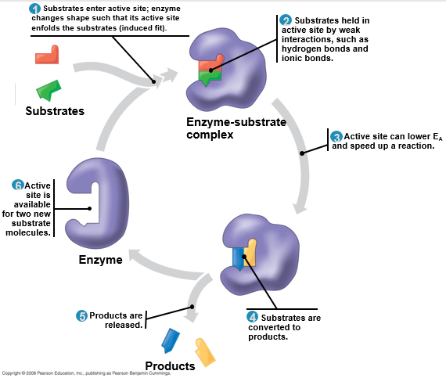
How does the active site lower activation energy?
- Orienting substrates correctly (to interact with each other)
- Straining substrate bonds
- Providing a favorable microenvironment i.e. pH
- Covalently binding to the substrate

cofactors and coenzmes
- Extra molecules (non-protein) needed by some enzymes
- Coenzymes are organic molecules that are required by certain enzymes to carry out catalysis (e.g. CoA or NAD).
- Cofactors are inorganic substances that are required for, or increase the rate of, catalysis (e.g. Zn²⁺ for alcohol dehydrogenase).

Regulation of enzyme activity
- Presence of an enzyme in a particular cell is controlled by turning genes on & off
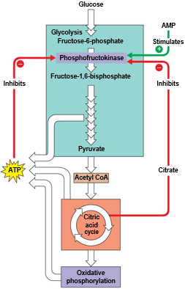
- Enzyme activity may be regulated by allosteric binding of a (non-substrate) molecule
- A regulatory molecule binds to a protein at one site and affects the protein’s function at another site (e.g. the active site) i.e. Phosphofructo-kinase
  - Inhibited by ATP (cellular respiration slows down when cell has plenty of energy resources)
  - Stimulated by AMP
  - Inhibited by citrate (helps synchronise glycolysis & citric acid cycle)
  - All are allosteric regulators of the enzyme’s activity

- May stimulate or inhibit
- ATP allosterically inhibits many catabolic reactions
- ADP allosterically stimulates many catabolic reactions

metabolism
A metabolic pathway is a series of chemical reactions in a cell with each reaction in a pathway being catalyzed by an enzyme. The metabolic pathway that requires energy and synthesizes molecules.
- Catabolic pathways break down complex molecules to simper ones, releasing energy
  - e.g. polymers to monomers
  - Cellular respiration is a set of catabolic pathways.
  - The energy produced is captured to do work within the cell.

- Anabolic pathways use energy to make bigger molecules from smaller ones
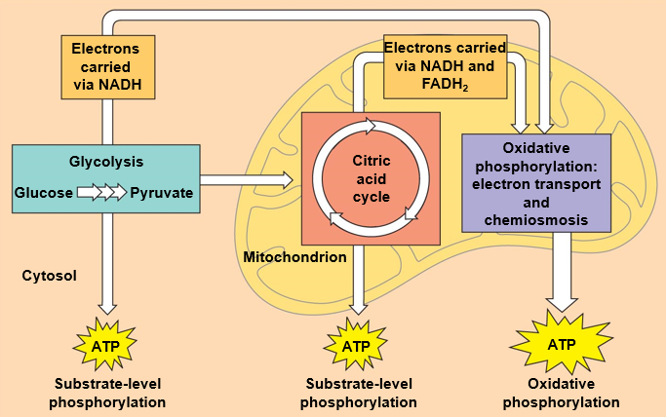
  - E.g. monomers to polymers
  - Energy consumption

metabolic pathways

Glycolysis (in cytoplasm)
Cytoplasm = Fluid + Organelles Cytosol = Fluid
Yield:
- 2 ATP (from ADP)
- 2 NADH + 2 H+

- NAD = Nicotinamide Adenine Dinucleotide
  - Derivative of niacin (vitamin B3)
  - NADH transported into mitochondria
  - Where it is used to make more ATP
  - 2 NADH yield about 6 ATP

Glycolysis = ‘sugar splitting’

Energy investment phase:
- ATP used to phosphorylate 6-C sugar
- Split into two 3-C sugars

Energy payoff phase:
- 3-C sugars rearranged energy captured

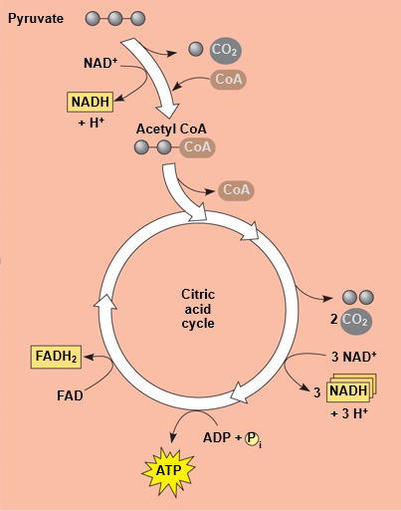
Link reaction (mitochondrial matrix)
Pyruvate + NAD⁺ -> NADH + CoA + CO₂ (oxidises pyruvate to acetic acid)

citric acid/Krebs cycle (mitochondriaL Matrix)
Oxaloacetate (4C) + CoA -> Citrate (6C)
Citrate + NAD⁺ -> 5C + CO₂ +NADH
Yields (per pyruvate):
- 1 ATP (via substrate level phosphorylation)
- 4 NADH
- 1 FADH₂

Oxidative phosphorylation

Electron transport
- NADH & FADH carry high energy electrons
- Electrons are passed to carriers in inner mitochondrial membrane
- Carriers pass on electrons and use the energy to pump hydrogen ions (H+) from matrix to intermembrane space
- Creates steep concentration gradient of H+ across inner mitochondrial membrane

chemiosmosis
ATP synthetase uses the potential energy stored in the H+ gradient to synthesise ATP from ADP

catabolic vs anabolic pathways
Catabolic pathways break down complex molecules to simper ones, releasing energy
- e.g. polymers to monomers
- Cellular respiration is a set of catabolic pathways, the energy released is captured to do work within the cell
Anabolic pathways use energy to make bigger molecules from smaller ones
- e.g. monomers to polymers
- Glutamate & glutamine - Two steps in the pathway (catalysed by glutamine synthetase):
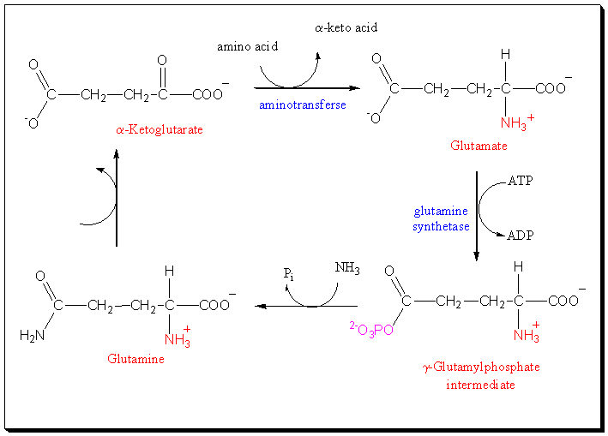
  - α-ketoglutarate -> glutamic acid
  - glutamic acid -> glutamine

  - α-ketoglutarate is a citric acid cycle intermediate
    - Many glycolytic and citric acid cycle intermediates act as precursors for anabolic reactions
  - Transamination of α-ketoglutarate makes glutamic acid (glutamate)
    - In transamination, an amino acid donates its amino group to an α-keto acid
    - Transaminases are most abundant in liver cells
    - Assayed in liver function tests (high levels in blood indicate liver damage)

  - Glutamine is a key intermediate in the synthesis of other amino acids
  - Several of these amino acids allosterically inhibit glutamate synthetase

Genetics
Haploid - The number of chromosomes in a gamete of an organism, symbolized by n. The haploid number in humans is 23.
Diploid – A cell or an organism consisting of two sets of chromosomes: usually, one set from the mother and another set from the father. In a diploid state the haploid number is doubled, thus, this condition is also known as 2n. In humans diploid number is 46.

Mitosis and meiosis
Mitosis (Growth, Repair and asexual production i.e. in Hydra):
Interphase
- The "resting" or non-mitotic portion of the cell cycle.
- It is comprised of G1, S, and G2 stages of the cell cycle.
- DNA is replicated during the S phase of Interphase
Prophase - the first stage of mitosis
- The chromosomes condense and become visible
- The centrioles form and move toward opposite ends of the cell ("the poles")
- The nuclear membrane dissolves
- The mitotic spindle forms (from the centrioles in animal cells)
- Spindle fibres from each centriole attach to each sister chromatid
Metaphase
- The Centrioles complete their migration to the poles
- The chromosomes line up in the middle of the cell ("the equator")
Anaphase
- Spindles attached to kinetochores begin to shorten.
- This exerts a force on the sister chromatids that pulls them apart.
- Spindle fibres continue to shorten, pulling chromatids to opposite poles.
- This ensures that each daughter cell gets identical sets of chromosomes
Telophase
- The chromosomes de-condense
- The nuclear envelope forms
Cytokinesis:
- Contractile ring (actin filaments contracted by the ‘motor’ myosin which) pinches cell until it splits into 2

Meiosis (Gamete production):
Prophase I
- The chromosomes condense and become visible
- The centrioles form and move toward the poles
- The nuclear membrane begins to dissolve
- The homologs pair up, forming a tetrad
  - Each tetrad is comprised of four chromatids - the two homologs, each with their sister chromatid
- Homologous chromosomes will swap genetic material in a process known as crossing over (abbreviated as XO)
  - Crossing over serves to increase genetic diversity by creating four unique chromatids
Metaphase I
- Microtubules grow from the centrioles and attach to the centromeres
- The tetrads line up along the cell equator
Anaphase I
- The centromeres break and homologous chromosomes separate (note that the sister chromatids are still attached)
- Cytokinesis begins
Telophase I
- The chromosomes may de-condense (depends on species)
- Cytokinesis reaches completion, creating two haploid daughter cells
Prophase II
- Centrioles form and move toward the poles
- The nuclear membrane dissolves
Metaphase II
- Microtubules grow from the centrioles and attach to the centromeres
- The sister chromatids line up along the cell equator
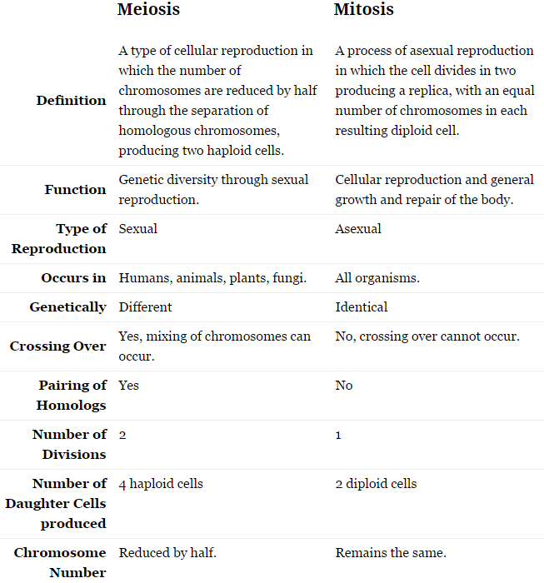
Anaphase II
- The centromeres break and sister chromatids separate
- Cytokinesis begins
Telophase II
- The chromosomes may de-condense (depends on species)
- Cytokinesis reaches completion, creating four haploid daughter cells

Mendel & ‘pre-molecular’ genetics
- A character is determined by a pair of factors (genes)
- Genes can exist in different versions (alleles)
- In a cross, each parent contributes one of its pair to an offspring (law of segregation)
  - offspring gets one of its pair from each parent
The expression of one allele may be dominant over another
Mendel’s 1st Law (Law of Segregation) states that each hereditary characteristic is controlled by two 'factors' (alleles) which segregate and pass into separate reproductive cells (gametes)
The law of independent assortment, originated by Gregor Mendel, stating that when two or more characteristics are inherited, individual hereditary factors assort independently during gamete production, giving different traits an equal opportunity of occurring together. Alleles of different genes assort independently of one another (depends on how they line up in the middle of the cell).

Inheritance
Autosomal dominant diseases | Autosomal recessive diseases | Sex linked diseases
Huntingdon’s disease | Cystic fibrosis | Haemophilia
Myotonic dystrophy | Sickle cell anaemia (problem with the gene for β-globin) | Red-green colour blindness

Co-dominance - the heterozygote displays both phenotypes
i.e. ABO blood group (Iª, I^{b}, i)
- Iª (A) & I^{b} (B) are co-dominant
- i (O) is recessive to both

Many characters are determined in part by genes and in part by environment i.e.
- Height
- Skin colour
- Risk of developing diabetes mellitis

Sex linked diseases
- Some genetic conditions affect males much more often than females
- Males have only a single X
  - so even recessive ‘disease’ alleles will always affect phenotype
- Females have two X’s
  - so a recessive allele on one may have no effect due to a dominant normal allele on the other
  - ‘carrier’

Chromosomal abnormalities
Structural changes
  - normal number of chromosomes, but something different
  - Deletion
  - Duplication
  - Inversion
  - Translocation

  - Chromosomes break and re-join wrongly
    - Radiation damage
    - May happen during meiosis (crossing-over goes wrong)
  - If many genes duplicated or deleted, big problems even if also have normal chromosome
    - Cri du chat syndrome (deletion of large part of chromosome 5) (cry of the cat)
  - Inversions & translocations may be ok, but …
    - Can have problems in meiosis when homologues try to pair up
      - One cause of infertility
Numerical changes
  - Extra or missing whole chromosome
    - Aneuploidy
    - Trisomy
    - Monosomy
  - Arise during meiosis
    - Non-disjunction at anaphase
    - Both chromosomes go the same way
  - Genes all there, but unbalanced numbers

Autosomal aneuploidy:
- Autosomal monosomy always has severe effects
  - Prenatal lethal
  - Early miscarriage
- Autosomal trisomy is usually prenatal lethal as well, but …
- Trisomy for some of the smallest autosomes is compatible with life
- Many foetuses with these do spontaneously miscarry, but some pregnancies go to term
  - Trisomy 21 – Down syndrome
  - Trisomy 18 – Edwards syndrome

Sex chromosome aneuploidy:
- Monosomy – i.e. XO – Turners Syndrome – Female and Sterile
- Trisomy – i.e. XXY – Klinefelter syndrome – Male with small testes and no functional sperm

physiology

Larger organisms need:
- Specialised structures to increase surface area for exchange of nutrients and waste products
  - Digestive system (intestines) for food and water
  - Respiratory system (lungs) to exchanges gasses with the environment
  - Excretory system (kidneys) to expel waste products
- Circulatory system to distribute materials within the body
  - heart & blood vessels, lymph

- Organ systems must work in a coordinated way
- Communication systems needed
  - Hormones (endocrine system)
    - Relatively slow & prolonged action
    - Widespread effects
  - Nerves (nervous system)
    - Faster, short-lived and more localised
- Homeostasis
  - Maintaining a steady state
  - Internal balance

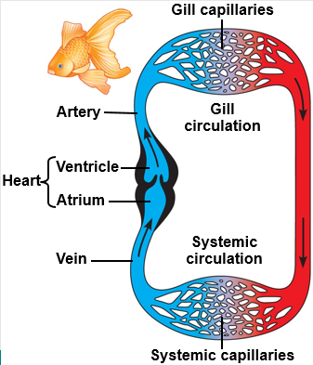
Circulation
- Animals that are several cells thick need a circulatory system
- Open circulatory systems:
  - Organs bathed directly in circulatory fluid
  - Body movements +/- Pump keep it moving
  - Low energy requirement
- Closed circulatory systems:
  - Circulatory fluid (blood) confined to vessels
  - Pump keeps it moving
  - More efficient & easier to regulate
  - Higher energy demand

Vertebrate circulatory systems
- Pump = heart
- Vessels
  - Arteries
  - Capillaries
  - Veins
- Either:
  - Single circulatory system (i.e. in Fish)
    - 2-chambered heart
    - Blood goes first to gills (gas exchange)
    - Then to rest of body
Or
  - Double circulatory system (i.e. in Humans and mammals)
    - A 4-chambered heart and two separate circuits
      - Pulmonary circuit (lungs)
      - Systemic circuit (other organs)
    - Permits high pressure for both lungs and rest of body

- Oxygenated blood enters the left atrium (LA) of the heart
- The LA contracts forcing the blood down into the left ventricle (LV)
- The thick muscles of the LV then contract forcing blood out of the heart through the aorta
- The blood travels around the body...
HEART ARTERIES ARTERIOLES CAPILLARIES VENULES VEINS HEART
Oxygen-rich
Oxygen-poor

- and via the vena cava returns to the right atrium (RA)
- The RA then contracts, forcing blood into the right ventricle (RV)
- The RV contracts forcing blood out of the heart through the pulmonary artery to the lungs
- The blood collects oxygen at the lungs and releases CO₂ and then returns to the LA via the pulmonary veins

Components of blood
- Fluid plasma
- Cells
  - Erythrocytes (red blood cells)
    - Gas transport (see later)
    - Clotting
  - Leukocytes (white blood cells)
    - Immune system
  - Platelets
    - cell fragments derived from megakaryocytes in bone marrow
  - Water
  - Salts (‘electrolytes’)
  - Plasma proteins
    - Osmotic balance
    - Clotting
    - Immune defence (antibodies)
    - Gas transport
  - Stuff in transit!
    - Nutrients
    - Wastes
    - Hormones

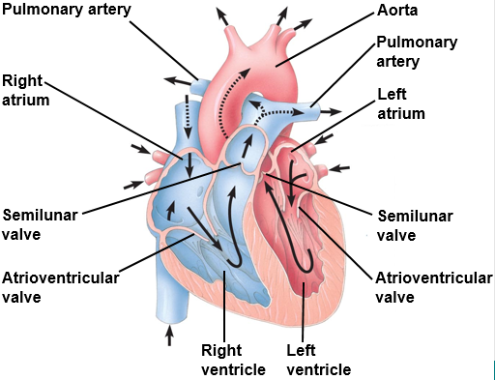
Heart
- Valves ensure 1-way flow & separate atria from the ventricles & the major arteries from the atria
- Four chambers:
- Atria
  - Collect blood at low pressure from veins
  - Relatively thin walls, but still with muscle cells
  - Contract to push blood via atrioventricular (AV) valves into…
- Ventricles
  - Very thick, muscular walls
  - Contract to push blood past semilunar valves into aorta/arteries
- Pacemaker (sinoatrial node (SAN))
  - Muscle cells with spontaneous rhythmic electrical activity
  - Spreads direct from cell to cell through gap junctions
  - Atria first – then ventricle apex – then top of ventricles
  - Electrocardiogram (ECG) picks up these currents
- Regulation of heart rate
  - Sympathetic and parasympathetic nerves to SA node
  - Hormones (e.g. adrenaline) also act on SA node cells

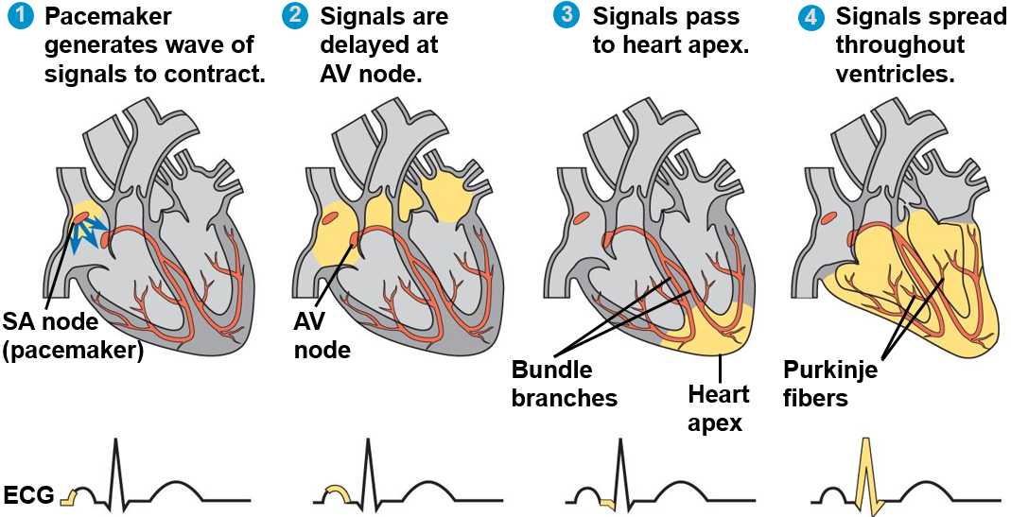
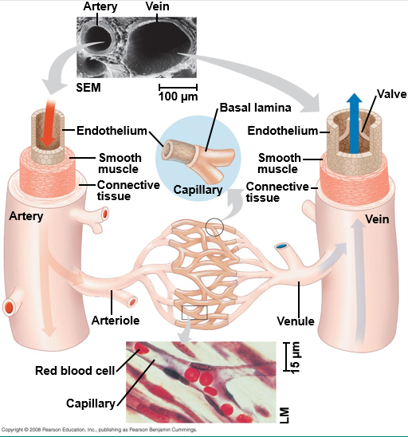

ARTERIES, VEINS and capillaries
- Arteries carry blood away from the heart
- Veins return blood to the heart

- 3 layers:
  - Thin, smooth endothelial lining
  - Muscle layer (‘smooth muscle’)
  - Connective tissue sheath – lots of collagen and elastic fibres

Arteries
- High pressure
- No valves
- Much thicker walls
  - Thicker smooth muscle layer
  - Thicker connective tissue layer
- Elastic recoil and some muscle contraction help pump blood and maintain blood pressure when heart relaxes
- Narrower lumen (space inside)
- Aorta – artery - arteriole
- Muscle of arterioles can contract / relax to regulate blood flow to different parts of the body

Veins
- Low pressure
- Thinner smooth muscle and connective tissue walls
- Wider lumen
- Valves to maintain unidirectional flow
- Surrounding muscle action and movement help move blood

capillaries
- Much thinner walls (single cell layer)
- Endothelium only
- Slow flow
- Massive total surface area
- Permit exchange between blood and tissues

Blood pressure
- Arterial blood pressure varies during the cardiac cycle
  - Ventricular contraction (systole) = highest pressure
  - Ventricular relaxation (diastole) = lowest pressure
- Readings affected by caffeine, sugar levels, height, weight, arterial vasoconstriction/dilation and adrenaline
  - Adrenaline binds to beta-adrenergic receptors to increase the force of contraction and firing rate
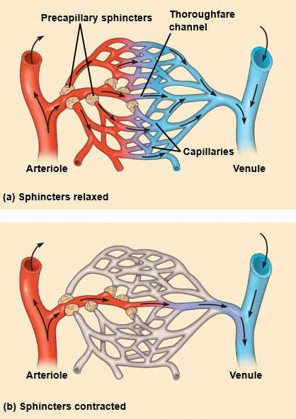
    - Causes arterioles to dilate therefore more blood
    - Arterioles leading to the gut constrict
      - b-blockers block b-adrenergic receptors and are used to treat hypertension (chronic high BP)
      - High blood pressure is bad because it ruptures small blood vessels

capillaries and exchange
- Flow of blood to capillary beds is regulated by arterioles
  - Nervous and hormonal signals
  - Increase / decrease in response to local demand
  - But some flow always maintained

- Interstitial fluid between capillary and cells of tissue

- Substances move:
  - Between blood & interstitial fluid
    - diffusion across thin capillary wall
  - Between Interstitial fluid & tissue cells
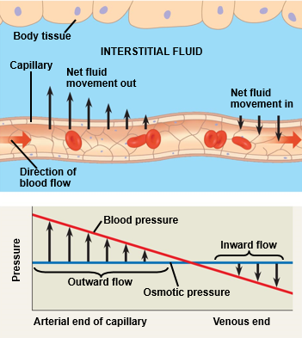
    - diffusion &/or transport

- Fluid lost / regained as pass though tissue
  - Net movement out at start – due to higher blood pressure than osmotic pressure
  - Back in at end – due to blood plasma proteins & osmosis

What substances move in and out of blood
- Gut:
  - IN - lipids & sugars & amino acids, carbon dioxide
  - OUT – oxygen
- Brain:
  - IN - carbon dioxide in
  - OUT - sugars & oxygen
- Lungs:
  - IN – oxygen
  - OUT - carbon dioxide

cardiovascular disease
- Very broad category
- Leading cause of deaths in rich parts of the world (though cancer is catching up …)
- Hypertension
  - chronic high blood pressure
- Stroke = loss of blood supply to part of brain
  - Blockage or rupture
- Heart attack = myocardial infarction
  - Interruption of blood supply to heart (blocked coronary arteries)

- But what causes the blockage / rupture?
  - Local atherosclerosis
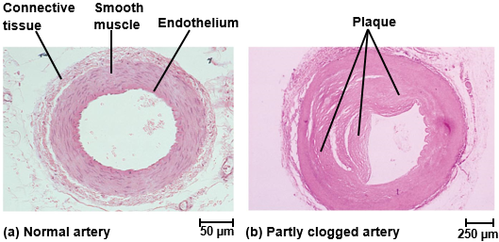
    - Accumulation of fatty deposits forming ‘plaque’
    - Hardening of artery (loss of elasticity)
    - Partial obstruction of artery
  - Thrombus
    - ‘loose’ blood clot (may have come from area damaged by atherosclerosis)

gaseous exchange (respiration)
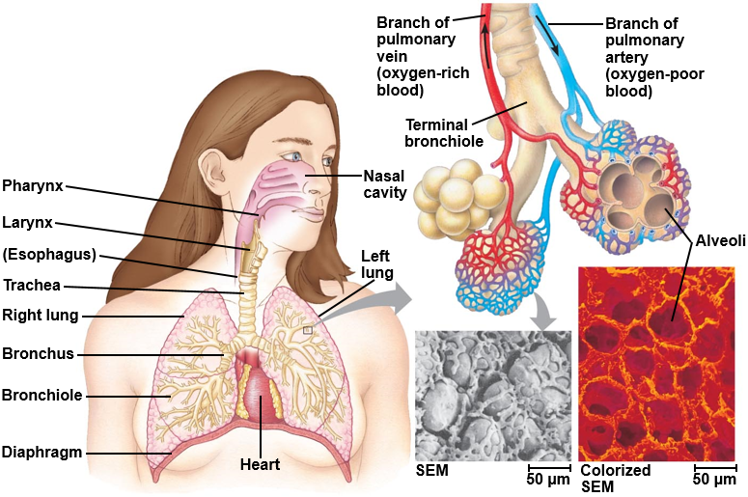
- Mouth and nasal cavity
  - Turbulent air flow – dust etc. trapped in mucous
- Larynx
  - Protects top of oesophagus
  - Used in vocalisation
- Trachea
  - Rings of C-shaped cartilage tissue help keep it open
- Bronchi
  - L & R principle branches, then smaller branches
  - Smooth muscle (which constricts airways in asthma when bronchi/bronchioles are inflamed), connective tissue
  - Lined with ciliated, mucous-secreting epithelium
- Bronchioles
  - Smaller and smaller branches
- Alveoli
  - Site of gaseous exchange
  - Provides large surface area so fat and lots of gaseous exchange
  - Good blood supply with short diffusion distance (1 cell thick alveoli)

alveoli and gas exchange
- Walls are very thin flat epithelium
  - 2 cells thick for gas to pass from alveoli into capillary and vice versa
- Capillaries wrap closely around
  - little interstitial fluid between capillaries & alveoli
- Total surface for gas exchange 50-100 m²
  - compared to 2m² for the external surface of the body

breathing (aka ventilation)
- Inspiration:
  - Contraction of external intercostal muscles > ribs move up and out > increased front- to-back dimension of thoracic cavity > lowers air pressure in lungs > air moves into lungs
  - Contraction of diaphragm > diaphragm moves downward > increases vertical dimension of thoracic cavity > lowers air pressure in lungs > air moves into lungs
- Exhalation
  - relaxation of external intercostal muscles & diaphragm > return of diaphragm, ribs, & ribs move down and in > restores thoracic cavity to pre-inspiratory volume > increases pressure in lungs > air is exhaled
Surfactant decreases surface tension which reduces the effort needed to expand the lungs and reduces the tendency for alveoli to collapse
In relaxed state, 2 opposing forces are in balance – Stretched elastic tissue wants to contract and the elastic chest wall wants to spring out
Internal intercostal muscles are only used in forceful exhalation such as coughing or during exercise and not in relaxed breathing.

control
- You can exert conscious control
  - rib intercostal muscles & diaphragm are ‘skeletal’ muscle
But normally …
- Basic rhythm of breathing is set by a network of nerve cells in the medulla of the brain
  - ‘respiratory centres’
  - Neurons fire rhythmically even in absence of input
- Cells of respiratory centre receive nervous feedback from other parts of the body
  - especially from stretch receptors in lung tissue

- Chemoreceptors monitor pH of body fluids
  - Higher [CO₂] forms more carbonic acid and lowers pH
  - Central (brain) chemoreceptors monitor CSF (cerebrospinal fluid)
  - Peripheral chemoreceptors monitor arterial blood
  - Lower pH causes rate and depth of breathing to increase
  - Removes CO₂ and pH rises again
    - Good example of homeostasis
- Coordinated with regulation of heart rate to remove CO₂ faster
- Under normal conditions oxygen level has little effect

gas transport in blood
- Oxygen has a relatively low solubility in water (~5ml /L)
- Respiratory pigments bind O2
  - mammalian blood then carries ~200ml / l
- Protein + cofactor including metal ion
  - Haemoglobin in vertebrates (red)
  - Haemocyanin in many insects and other invertebrates (blue)
- Vertebrates keep their haemoglobin in cells
  - red blood cells (erythrocytes)
  - Thin, biconcave – more surface area for exchange
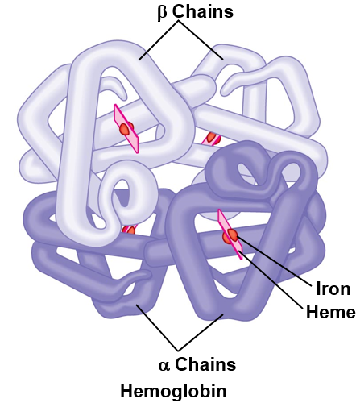
  - Lose their nuclei – more volume for Haemoglobin
  - Lose their mitochondria – low metabolism and O2 usage
  - Short life-span – made in bone marrow - ‘recycled’ in spleen

haemoglobin
- Four polypeptide subunits
- 2 alpha globin chains + 2 beta globin chains
- Each plus a haem (heme) cofactor with iron atom
- Each iron binds one O₂ molecule

- Cooperative binding
  - Each O₂ that binds increases affinity for the next
  - Each O₂ that offloads makes next offload easier

- Adaptions of RBC:
  - Thin and biconcave
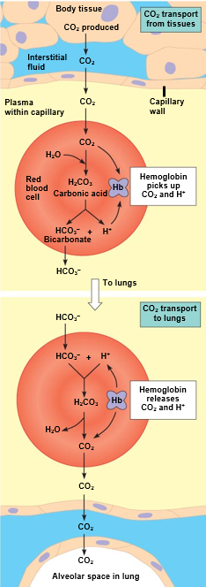
  - No nuclei – therefore larger surface area
  - No mitochondria – therefore decreased use of O₂
  - Anaerobically respire
  - Short life cycle – made in bone marrow and recycled in the spleen
Without a nucleus RBCs cannot regenerate cellular components, including proteins such as haemoglobin. As the RBC ages, the Hb starts to degenerate and break down, becoming less efficient at carrying oxygen and so the RBC itself has reduced functionality. Older (we're talking a few months old) RBCs are destroyed rather than occupy space that could instead be utilised by a fresh and efficient younger RBC.

- Sickle cell disease
  - Change in gene for beta-globin
  - Single amino acid difference
  - Haemoglobin molecules tend to stick together and form fibers – especially at low oxygen levels
  - Makes RBC less flexible/deformed
  - May jam when pass through capillaries
    - Heterozygotes have no or minor problem with Hb
    - But are less severely affected by malaria
    - Malaria parasite (Plasmodium) has difficulty surviving in these RBC

Co₂ transport in blood
- CO₂ has a relatively high solubility in water
Also …
- Can be converted to bicarbonate ions HCO₃⁻
  - Catalysed by enzyme carbonic anhydrase in RBC
- Can bind to haemoglobin

Overall:
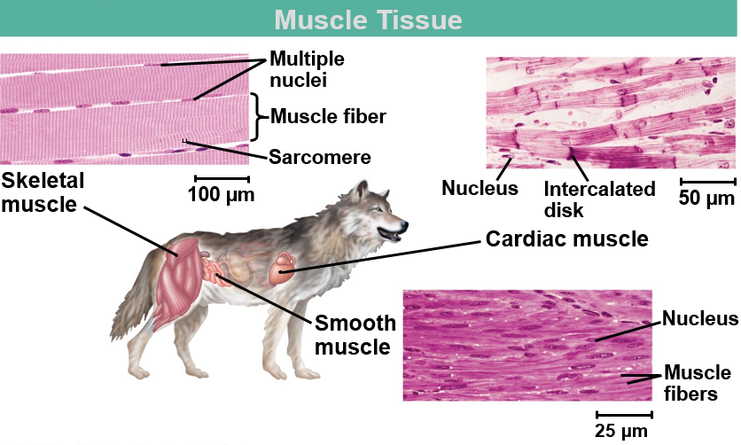
- 70% as HCO₃⁻ in plasma & H⁺ bound to RBC
- 23% bound to Hb
- 7% as dissolved CO₂

Muscle

Types of muscle
Skeletal Muscle:
- Responsible, with the skeletal system, for locomotion & other movement
- ~25% of human body weight
- Attach via tendons to bones, and articulate the skeleton
- Made up of muscle ‘fibres’: giant multinucleate cells
- Cells striated (look ‘striped’ down a microscope)
- Long - Length may be entire muscle length – diameter 10-100μm
- Each cell activated by signal from motor neuron
Cardiac Muscle:
- In heart
- Smaller cells – single nucleus
- Striated
- Branching & held together by ‘intercalated discs’
  - strong attachment + gap junctions to spread electrical signal
- Most cells have no connecting nerves
Smooth Muscle:
- In arteries and veins, bronchi, walls of the intestine etc.
- ‘ordinary’ cells with single nucleus & tapered ends
- No striations (less regular organisation of molecules inside)
- Usually controlled by autonomic (automatic) nervous system
- Not all cells have a nerve – signals can spread cell-to-cell
- May also respond directly to stretch
- Slow, sustained contractions
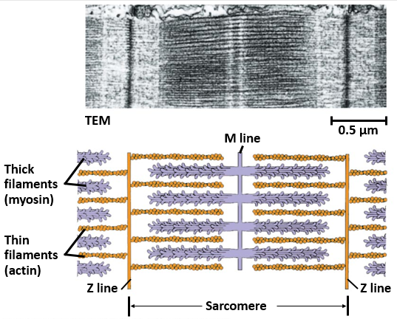
- Contraction depends on actin & myosin interaction
  - as in striated muscle
  - but not all at once

organisation
- Muscle is bundle(s) of muscle fibres
- Muscle fibre = giant multinucleate cell
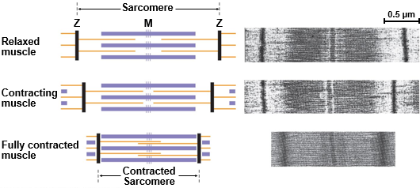
- Each fibre contains bundle of myofibrils (protein fibres)
- Sarcomere (Z line to Z line) of the myofibril is the unit/region of contraction
  - Includes M line
  - Thick filaments
    - Myosin
      - Protein
      - Individual myosin molecules have tail & heads
      - Different protein sub-units
      - Thick filament = bundle of these
      - Heads stick out
      - Interact with actin
  - Thin filaments
    - Actin
      - Protein
      - Filaments made of globular actin monomers
      - Same as microfilaments found in many cell types
        - part of cytoskeleton

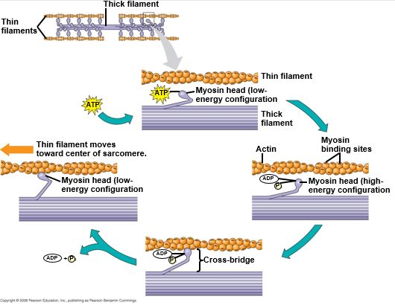
sliding filament model
- Myosin heads “walk along” actin
- Directional
- Pull Z lines closer together
- Consumes ATP
  - Skeletal muscle cells have large glycogen stores
  - And many mitochondria to make ATP

- A nervous impulse arrives at the neuromuscular junction, which causes a release of a chemical called Acetylcholine. The presence of Acetylcholine causes the depolarisation of the motor end plate which travels throughout the muscle by the transverse tubules, causing Calcium (Ca⁺) to be released from the sarcoplasmic reticulum.
- In the presence of high concentrations of Ca⁺, the Ca⁺ binds to Troponin, changing its shape and so moving Tropomyosin from the active site of the Actin. The Myosin filaments can now attach to the Actin, forming a cross-bridge
- The breakdown of ATP to ADP and P_{i} releases energy which enables the Myosin to pull the Actin filaments inwards and so shortening the muscle. This occurs along the entire length of every myofibril in the muscle cell.
- The Myosin detaches from the Actin and the cross-bridge is broken when an ATP molecule binds to the Myosin head. When the ATP is then broken down the Myosin head can again attach to an Actin binding site further along the Actin filament and repeat the 'power stroke'. This repeated pulling of the Actin over the myosin is often known as the ratchet mechanism.
- This process of muscular contraction can last for as long as there is adequate ATP and Ca⁺ stores. Once the impulse stops the Ca⁺ is pumped back to the Sarcoplasmic Reticulum and the Actin returns to its resting position causing the muscle to lengthen and relax.

regulation of contraction
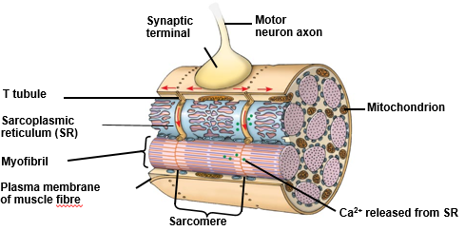
- T tubules run through the cell
  - Indentations of plasma membrane
- Sarcoplasmic reticulum wraps around myofibrils
  - Calcium ion store
  - Muscle cell’s smooth endoplasmic reticulum

- Troponin & tropomyosin coat thin filament
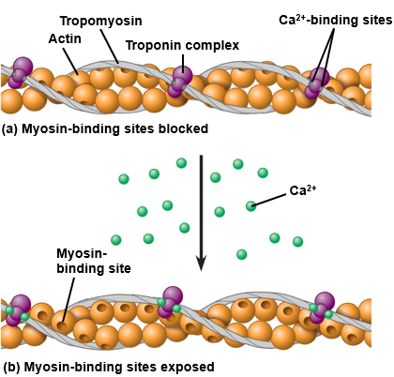
- Can block or expose myosin-binding sites
  - Determines if actin/myosin interaction and contraction can occur
- Calcium ions determine which state prevails

- Motor neuron signals to muscle fibre
  - special kind of synapse called a neuromuscular junction
- Generates electrical signal in muscle cell
  - Action potential
- T-tubules carry electrical signal throughout cell
- Trigger release of calcium ions from sarcoplasmic reticulum
- Ca2+ binds to troponin on thin filaments
- Troponin pushes tropomyosin aside
- Exposes myosin-binding sites
- Contraction can occur!
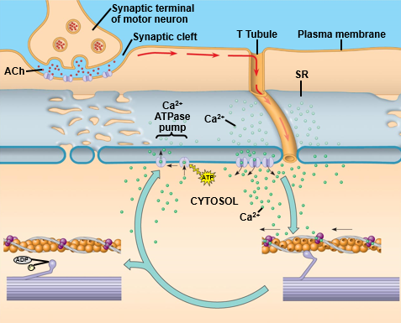
  - Until Ca²⁺ pumped back into sarcoplasmic reticulum

Nerves

Overview
- Cells that carry signals are called nerve cells or neurons.
- The nervous system can be a diffuse system (nerve net (i.e. in Hydra)) or a system with a specialised area for central processing (brain and/or ganglia (concentrated area of neurones))
Vertebrate nervous system has two anatomical divisions:
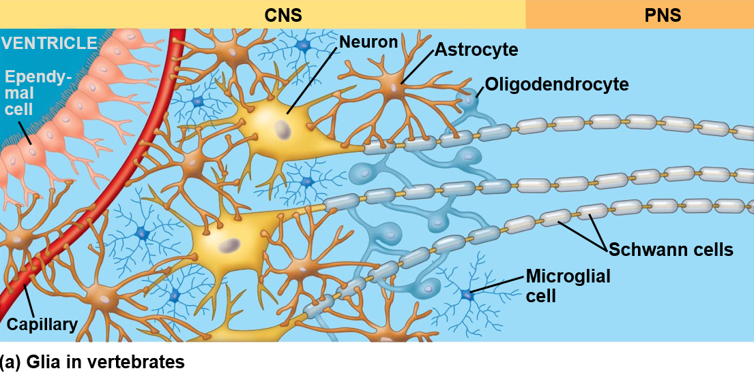
- Central nervous system (CNS)
  - Brain
  - Spinal cord
- Peripheral nervous system
  - Transmits signals to & from the rest of the body
  - Sensory information in (afferent (accept/sense) neurons)
  - Instructions out (efferent (exit/send) neurons)
  - Local ganglia

- Nerve cells = neurons
  - Cells that actually carry signals
  - Sensory cells are specialised neurons

- Supporting cells
  - Glial cells
  - Many different kinds & more glial cells than neurons
  - Functions include:
    - Nourish – i.e. Astrocyte (increase blood flow therefore more O₂)
    - Protect – i.e. Microglial cell (protects and links immune and nervous system)
    - Electrically insulate – myelin sheaths made up of Schwann cells

neurone structure
- Dendrites
  - Multiple (short) extensions to receive incoming signals
- Synaptic terminal
  - Signal is chemical (neurotransmitter)
  - All or nothing transmission of impulse

- Cell body
  - Nucleus
  - Mitochondria – ER - Golgi
- Axon
  - (Single) long extension to send signals via action potentials

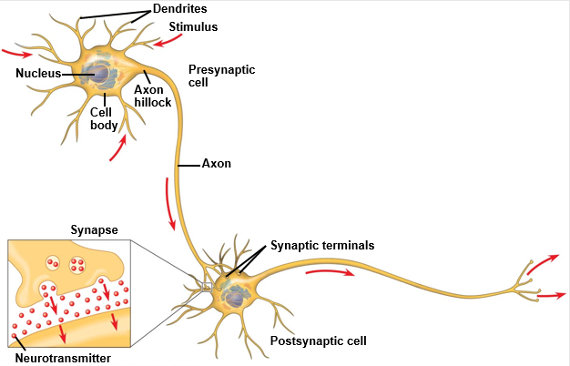
Diversity of neurone structure and function
- Sensory neurons
  - pass on signals from sensory cells
  - or may themselves have specialised sensory extensions
- Interneurons (relay) neurones
  - pass on & help integrate signals
  - Brain is mostly interneurons
- Motor neurons
  - signal to muscle cells

Signals and synapses
- Signal that travels down an axon is electrical
  - Action potential
- Neurons transmit signals to other cells at special junctions called synapses
  - Neuron – neuron
  - Motor neuron - muscle (neuromuscular junction)
- Signal at a synapse is usually chemical
  - Neurotransmitter - e.g. acetylcholine
- Some synapses are electrical
- Synapses may be stimulatory or inhibitory
- Determine whether post-synaptic cell fires its own action potential

cns vs. pns
CNS | PNS
Comprises of brain and spinal cord | Connects CNS to rest of the body
Handles involuntary information | Handles voluntary information
Gathers information about, and responds to, changes in the environment. coordinates the information and sends impulses along motor neurons to the effectors, which bring about a response | Comprises of the autonomic nervous system and the somatic nervous system.  The nerves and ganglia outside of the brain and the spinal cord

action potentials

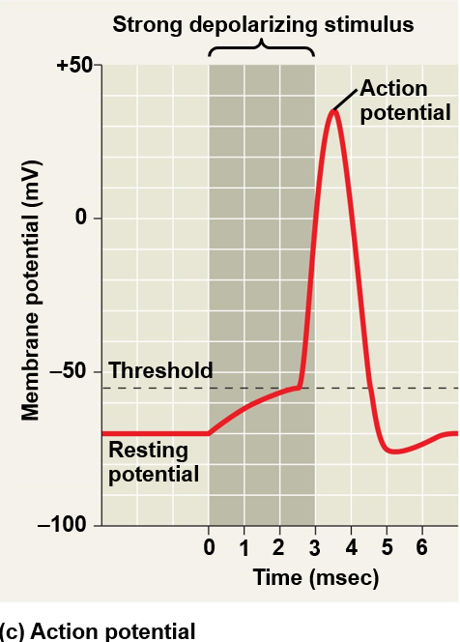
resting potential maintenance
- Sodium-potassium pump (active transport)
  - Active transport, powered by ATP
  - Each cycle moves 3 Na⁺ out & 2 K⁺ in
  - Results in ion gradients across the membrane: potential energy
- Ion channels (diffusion)
  - Na⁺ channels & K⁺ channels
- Overall effect is the resting potential of -70mV (inside if the cell)

action potential generation
- A neuron’s electrical signal consists of a wave of depolarisation of the axon membrane
  - Transiently goes from -70 mV to about +40mV then returns to -70mV
- Depends on Voltage-gated ion channels

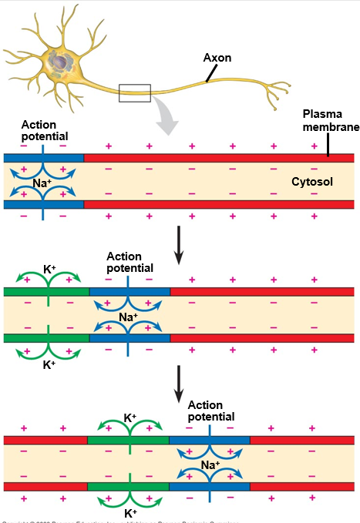
- When triggered by arrival of action potential, voltage-gated Na⁺ channels open temporarily (only if threshold potential is met)
  - Na⁺ rushes in (because more outside than in)
  - Inside of axon becomes more positive
  - Then they shut
- Voltage-gated K⁺ channels open
  - K⁺ rushes out (because of diffusion)
  - Inside of axon becomes negative again
  - Eventually they shut
- Back to resting state
- Na⁺-K⁺ pump ensures gradients maintained

Myelin and rapid conduction
- Many axons have an insulating sheath of myelin
  - mostly layers of membrane lipid
- Made by Schwann cells (type of glial (supporting) cell)
- Main function is speeding up nerve signal
- Current spreads directly between Nodes of Ranvier
- Voltage gated channels present only at nodes – boosters
- A.P. jumps from node to node – Saltatory Conduction

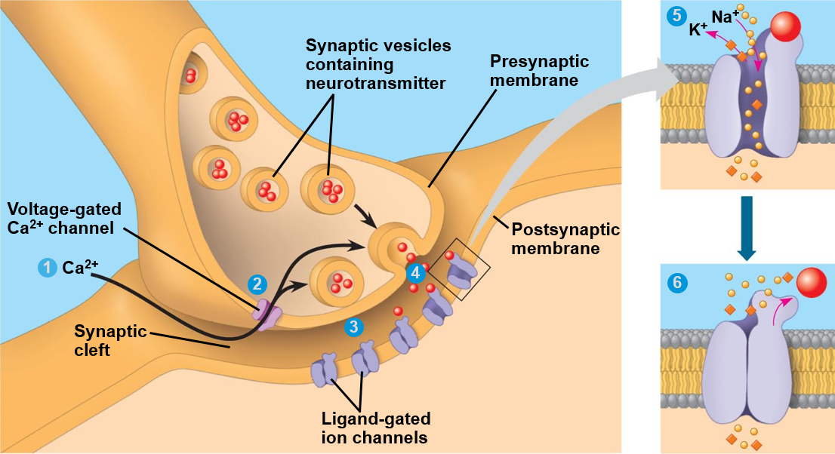
synapses
- How do signals pass from one cell to the next?
  - Nerve-nerve (synapses)
  - Nerve-muscle (neuromuscular junction)
- Electrical synapses have gap junctions and directly pass on current via ions and are very fast. Almost instantaneous.
- Chemical synapses are much more common
  - carries the signal across a gap: neurotransmitter
    - released by the presynaptic cell
    - diffuses across gap
    - binds to receptor on postsynaptic cell
    - postsynaptic cell responds
- Neuromuscular junctions are chemical synapses

Process
- Action potential reaches synaptic terminal of axon
- Opens voltage-gated Ca²⁺ channels in membrane
- Ca²⁺ enters causing exocytosis of vesicles containing neurotransmitter
- Neurotransmitter diffuses across gap and bind to receptors on postsynaptic cell
- Receptors are ligand-gated channels, and open
- Ions enter/leave postsynaptic cell, which changes its membrane potential
- Signal ends when neurotransmitter diffuses away &/or is broken down, and channels shut

effect on the next cell
- Neuromuscular junction
  - Big area of synapse
  - Action potential always fires in muscle cell if the threshold potential is met
  - Neurotransmitter = acetylcholine which is excitatory at neuromuscular junction

- Nerve-nerve synapses
  - Receiving neuron may have lots of synapses
  - Effect of a single synapse can be
    - Excitatory (depolarising) – i.e. Dopamine and Glutamate
    - Inhibitory (hyperpolarising) – i.e. Serotonin, Glycine and Endorphins
  - Summation of input determines whether an action potential fires

- Many drugs & toxins act by affecting neurotransmitter action
  - Botox (Clostridium botulinum toxin) inhibits Acetylcholine release
  - Amphetamines stimulate glutamate release
  - Opiates, like heroin, mimic endorphins

from gene to protein
- DNA and RNA are polynucleotides
- Information is encoded by the order of nucleotides (bases)
- A-G-C-G-T-T is different to A-T-T-G-C-G
- 3 nucleotides/bases = 1 codon = an amino acid (can be coded for by multiple codons)
- e.g. codon AUG specifies the amino acid methionine (start codon) UAA, UGA AND UAG = stop codon

transcription (in nucleus)
- RNA polymerase is the enzyme that catalyses transcription to make RNA
- Recognises promoter (characteristic) sequence at start of gene
  - Help from proteins that regulate transcription
- Local unwinding of DNA double helix from 5’ end first
- RNA polymerase adds free complementary bases with U instead of T
- Makes messenger RNA: mRNA – (shorter then DNA as it only codes for one gene)
  - In eukaryotes, a mRNA molecule is processed before it leaves the nucleus
    - Ends are modified:
      - Guanine cap to 5’ end and polyA tail on the 3’ end
        - Cap promotes translation, 5’ intron excision and regulates nuclear export
        - Tail protects the mRNA molecule from enzymatic degradation in the cytoplasm
    - Introns removed (eukaryotes only)
    - Then transported through nuclear pore into cytosol

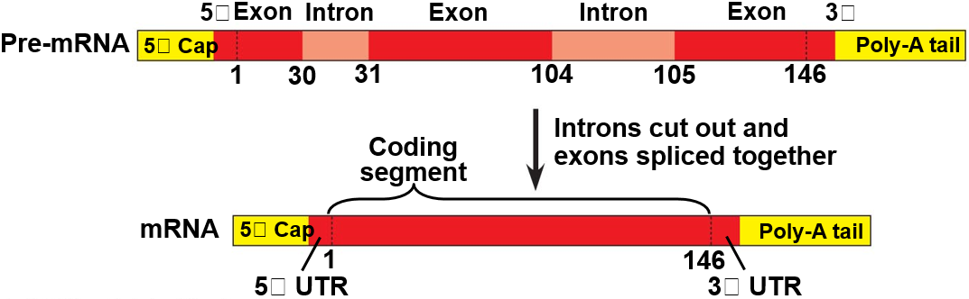

- The coding sequence of most eukaryotic genes is interrupted by introns
- Gene has non-coding introns and coding exons
- May be much more intron than exon

- Still controversial as to why eukaryotic genes are like this
  - Helps evolution of new proteins?
  - Undesirable insertion of viral / transposon DNA?

Translation (ribosome)
- Ribosome coordinates & catalyses protein synthesis
  - Large complex of many proteins + special RNA molecules (rRNA)
  - Made up of large and small subunits
- Translation begins at start codon - AUG: methionine
- Amino acid brought in by tRNA (transfer RNA) adaptor as ribosomal subunits assemble on the mRNA
- Ribosome moves along message
  - 1 codon at a time
  - Helps each new tRNA come in
  - Makes peptide bonds between amino acids
- One tRNA for each codon
  - Recognises codon with base pairing
  - Carries amino acid
- End of message is marked by stop codon
  - 3 of the 64 codons are stop codons (60 ‘normal’ codons, 3 stop codons, 1 start codon)
  - Ribosome detaches – protein released
  - 2 GTP -> 2GDP used to release the polypeptide from the ribosome
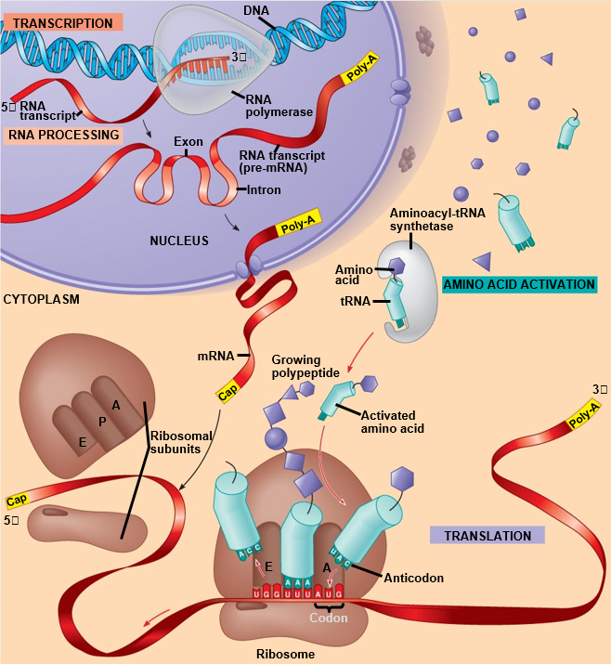
May be several ribosomes working away on a single mRNA

Mutation and its consequences
- A mutation is an alteration in the coding sequence of a gene (or genes)
- Deletions are mutations affecting many genes as it causes a frameshift
- Point mutations affect a single gene
  - A single nucleotide change can have a dramatic affect
- Effect of a point mutation in an intron sequence is usually nothing because introns are removed before mRNA translated

point mutations
Base substitution
- Silent – change to a synonymous codon
  - No effect on protein
- Missense – change to a codon for a different amino acid
  - Protein folding and function may be affected mildly or severely
- Nonsense – change to a stop codon
  - Truncated (shortened by chopping part off) protein – usually non-functional

Base insertion or deletion
- Changes reading frame by frame shifting
  - Completely different amino acids
  - Non-functional protein
  - Can cause missense or nonsense
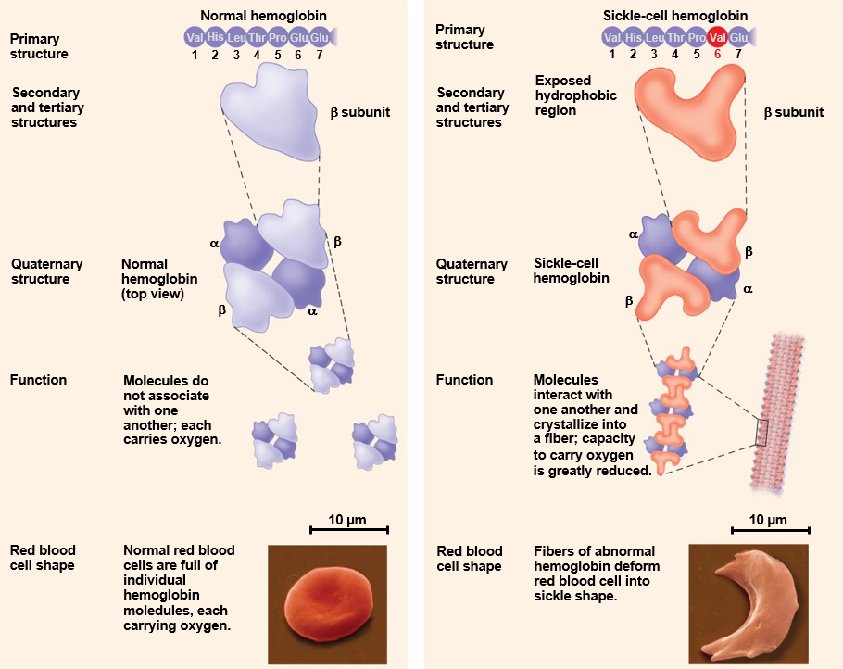
Example of a point mutation:
- β-globin gene
- Sickle allele
- 1 nucleotide change: missense
- Codon for glutamate -> codon for valine
- Changes shape of (haemoglobin
- Tends to form fibres and messes up oxygen transport which causes breathlessness.
- Disrupts structure and function

evolution

causes of microevolution
- Genetic mutations – small changes to genetic sequence over time
  - Genetic mutations are the cause of variation in organisms.
  - Mutations cause gene loci to have multiple (>1) alleles = polymorphic.
  - Polymorphic = more than one allele of a gene i.e. Human blood type, 3 different alleles
  - Recombination of these alleles of different genes increases the possibility of favourable phenotypes
- Gene flow
  - Gene flow caused by migration of individuals from one population to another.
  - Movement of breeding individuals between different populations moves alleles.
  - Gene flow tends to reduce the genetic differences between populations – makes gene pools more similar.
- Non-random mating
  - Non-random mating: Inbreeding, Assortative mating or Sexual selection
    - Inbreeding increases number of homozygotes at all loci, and decreases heterozygotes
    - Assortative ‘Like’ mating - causes population to subdivide according to certain traits. Increases no. homozygotes at certain loci. E.g. Humans choose humans of similar IQ.
    - Sexual selection - Males compete for females. Females choose males with certain characteristics. Mating rituals.
- Genetic Drift
  - Refers to allele frequencies of a gene changing at random.
  - Caused by only some members of the population being able to reproduce (randomly) – so not all alleles in population are passed on to next generation because some individuals do not reproduce.
  - Bottleneck effect – reduction in population size causes decrease in genetic diversity in population.
  - Founder effect – population started by only a few individuals so has limited genetic diversity.
- Natural Selection
  - Process by which organisms adapt to their environment (biotic & abiotic factors).
  - Natural selection acts on traits (many may be controlled by >1 gene) so there may be a range of phenotypes.
e.g. height controlled by several genes & environmental factors so = range of heights in a population
Natural selection can affect the frequency of a trait in a population in 3 different ways, depending on which phenotypes are favoured:
- Directional selection – when an extreme phenotype is favoured. Takes a long time due to long generation time. E.g. Height of giraffes or the size of horses
- Stabilising selection - When an intermediate phenotype is favoured then extreme phenotypes are selected against. Reduces variation. E.g. Weight of human babies kept between 3-4kg.
- Disruptive selection - Two or more extreme phenotypes favoured over intermediate types i.e. sneaky or alpha males get the females

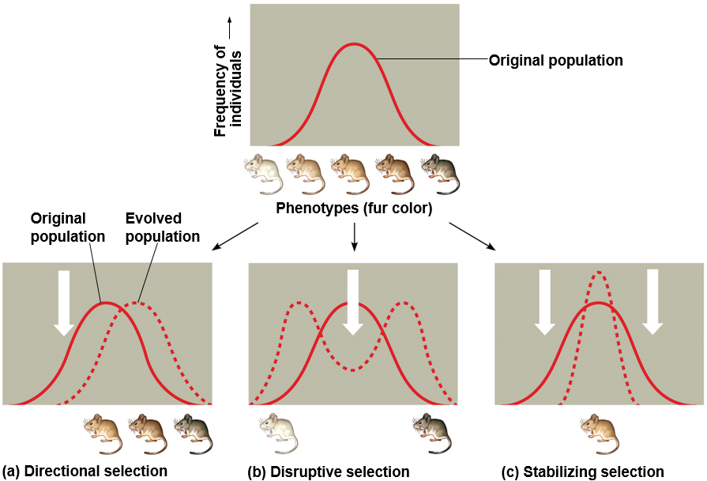
macroevolution
- Microevolution = small changes in allele frequency over short period of time.
- Macroevolution = larger number of changes – results in a new species (speciation) (over many generations)
- Speciation = Splitting of one species into 2 or more species, or change of a species into a new species.
- Species = only able to reproduce with other members of its species to produce fertile offspring.
  - So, members of a species are reproductively isolated from other species.

Natural Selection and the Hardy-Weinberg Equilibrium

Natural Selection
- Natural selection = environment causes organisms that are most fit to survive and therefore reproduce – results in adaptation to the environment
Natural selection leads to evolution.
- Evolution = Organisms descend from common ancestors (shared characteristics) but develop characteristics (genetic and phenotypic) that make them more suited to their environment over time.
- Survival of the fittest = Over time, favourable heritable traits become more common/frequent and unfavourable traits become less common
Genetic changes are caused by mutations, genetic drift, gene flow and natural selection.
- Mutation = changes in genes to produce different alleles (and therefore phenotypes).
- Genetic drift = change in allele frequencies at random.
- Gene flow = when new genes enter or leave a population by migration.
- Natural selection:
- Environment changes so organisms that are better adapted for new conditions survive (carrying the advantageous alleles)
- Gene pools of different populations become increasingly different
- Changes occur in allele, genotype & phenotype frequencies
- Eventually a new species evolves

HARDY-WEINBERG EQUILIBRIUM
p² + 2pq + q² = 1 p + q = 1

- p = frequency of dominant allele (L)
- q = frequency of recessive allele (l)
- p² = frequency of homozygous dominant individuals (LL)
- q² = frequency of homozygous recessive individuals (ll)
- 2 pq = frequency of heterozygous individuals (Ll)

Assumptions/principles:
- No mutations
- No gene flow (immigration or emigration)
- Random mating
- No genetic drift (=Infinite population size (as genetic drift is inversely proportional to population size))
- No selection
Proportion of alleles in a population will remain constant so long as assumptions are met.
IF NOT FOLLOWING HW PRINCIPLES, SPECIES IS EVOLVING

Gene pool = total of all the genes/alleles in the population.
- Inbreeding -> Loss of genetic diversity
  - Higher frequency of deleterious alleles which may result in reduced fitness (ability to reproduce successfully) for individuals
  - Inbreeding depression
    - I.e. Florida panther due to habitat reduction which led to a population of <50.
    - Father – daughter mating has been observed in several cases and captured males have up to 95% of their sperm malformed
- Genetic drift
  - Change in allele frequencies over time
  - Occurs at random and not driven by changes to the environment
  - Effects are less severe in larger populations
    - i.e. random chance due to random mating leads to a change in the proportion of different coloured oysters

- Genetic bottleneck
  - Significant portion of population is killed or does not breed and as a result, the size of the breeding population is drastically reduced
  - Leads to the reduction of allelic diversity at a greater rate than heterozygosity
  - Increases drift and inbreeding
  - Causes ‘founder effect’ – where the remaining few individuals serve as the ‘founders’ for any future populations
    - i.e. Pink Pidgeon in Mauritius
    - from 9 in 1980’s to over 400 but populations suffers high levels of infertility, likely as a result of the genetic bottleneck

population and community ecology
- Habitat = where an organism lives.
- Niche = the ‘role’ an organism plays in its environment.
= where it lives, what it eats, where & when it feeds,
when it is active etc. The interactions an organism has with other organisms and its environment.
  - Every species has its own niche.
- Carrying capacity = Maximum number of organisms of a species that a habitat can support continuously.
  - The closer the population to the carrying capacity – the more difficult it is for organisms to survive. Food becomes more scarce and predation risk is greater
- Population = a group of individuals of the same species occupying the same area of space.
- Community = populations of different species which live in the same area of space and are therefore able to interact with one another.
- Demography = the study of population change over time.
- Meta-population = Populations which influence each other e.g. through immigration and emigration, can lead to meta-populations; where a number of smaller local populations are linked.

population dynamics
Understanding population ecology requires an understanding of the biotic and abiotic factors affecting the individuals in the population.
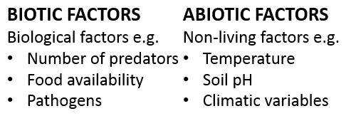

- Populations remain stable when the number of individuals entering a population = the number of individuals leaving

patterns of dispersion
- Clumped - Most common pattern of dispersion. Often dictated by resource abundance e.g. light or food availability. Can increase survival due to increased vigilance. i.e. Fruit bats
- Uniform - Driven by interactions between individuals, usually through conflict over resources e.g. territoriality. i.e. Lions
- Random - Dispersal of individuals is independent of the location of other individuals. i.e. Daisies or other wild flowers

Drivers of dispersal patterns

Competition for resources
- Plants compete for:
  - Light, CO₂, H₂O, minerals, pollinators, space/sites for spores and seeds to germinate.
- Animals compete for:
  - Food, access to mates, breeding sites, shelter from predators

Competition can be intra or inter specific:
- Intraspecific competition = competition between individuals of same species
- Interspecific competition = competition between individuals of different species i.e. 2 species of Paramecium
Competitive exclusion principle = no two species can occupy same niche at the same time indefinitely – one will be outcompeted”

- Some organisms specialise when interspecific competition is a factor. E.g. Galapagos finches, when each species lives on own then beak of intermediate size so can eat range of seeds of different sizes.
- When two or more species of finches live in same place then natural selection promotes specialisation of beak size through resource partitioning = Character displacement.
- Resource partitioning = each species occupies its own distinct niche so that the species do not lead to the demise of each other. I.e. the different perching areas of Lizards

Predator-Prey Interactions
- Predators and prey have special relationship and influence numbers of each other.
- When a predator relies/is dependent on one source of prey, it creates a predator-prey cycle
- Predators eat prey therefore decreases prey population
- Always fewer predators than prey.
- Predator cycle always lags behind prey
- This may be because if predator numbers increase quickly, they eat too many prey

biodiversity conservation
Biodiversity = the variety of life on Earth plus the habitats that his life encompasses.
Biodiversity forms the life system for planet Earth. Without it, there would be no life on Earth & we would not survive.

importance
- Food - 80% of world’s food comes from ~20 plants
- Medicine – vast range of drugs derived from plants e.g. Taxol derived from Yew tree bark used in chemotherapy.
  - Only a small % of plants have been tested.
- Ecological services – nutrient cycling & regulation
- Industrial materials – e.g. Building materials, oil, rubber, adhesives etc. All derived from biodiversity.
- Aesthetic/leisure – value associated with enjoying time in or looking at biodiversity and nature.

measuring biodiversity
- Species diversity
  - Number of different species in an area combined with the abundance of each species. High abundance and number of species = high species biodiversity and no/little dominance
- Functional diversity
  - Measuring biodiversity by the number of functionally different species is an alternative that accounts for the ecological attributes of each species.
  - Takes functional role and niche into account
If the health of an ecosystem is measured by how well it functions, then the loss of a species may not be detrimental to the system as a whole. Another functionally similar species may fulfil the same role within the ecosystem (called an analogue species) using extant species to replace those lost from an ecosystem. I.e. using an Aldabran Giant Tortoise to fill the ecological niche left by the Mauritian Giant Tortoise.

Threats to biodiversity
- Habitat Loss - Fragmentation and degradation of land for space, shelter, fuel and food.
- Introduced species which kill native species. Either accidentally or on purpose as a biological control i.e. Cane toad in Australia to control the cane beetle.
- Overharvesting
- Overexploitation to show off affluence, use in Chinese medicine or food
- Pollution
- Human-induced climate change

Conserving biodiversity
Five Stages of Species Restoration:
- Know your species
- Understand limiting factors
- Intensive management (critically endangered species)
- Population management (addressing controlling factors)
- Monitoring & research

(Professor Carl Jones)
- Conservation is expensive, long-term and labour-intensive and to succeed needs to be targeted.
  - Landscape or species-level?
  - In situ or ex situ?
  - Which species should be prioritised?
  - Train local staff or bring in international expertise?

